IST 718 Big Data Analytics Notes

Table of Contents

Week 1 1

# Week 1

* What are advanced data analytics?
  + In the corporate space, advanced analytics is a term used for describing how algorithms, data, and computing power can describe, predict, or optimize for a specific business function.
* OSEMiN
  + Obtain, Scrub, Explore, Model, and Interpret
* The 7 C’s
  + Choose your questions
  + Collect data
  + check data
  + clean data
  + chart analysis
  + customize analysis
  + Communicate
* Crawl, Walk, Run
  + Describe, Model, Choose
  + Forecasting, Inferring, Picking(choosing)
  + Choose, Machine Learning

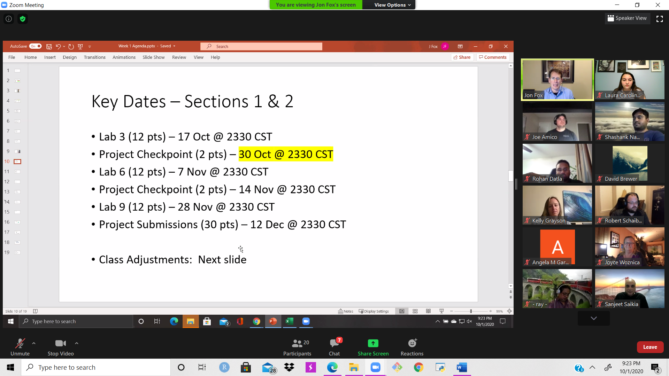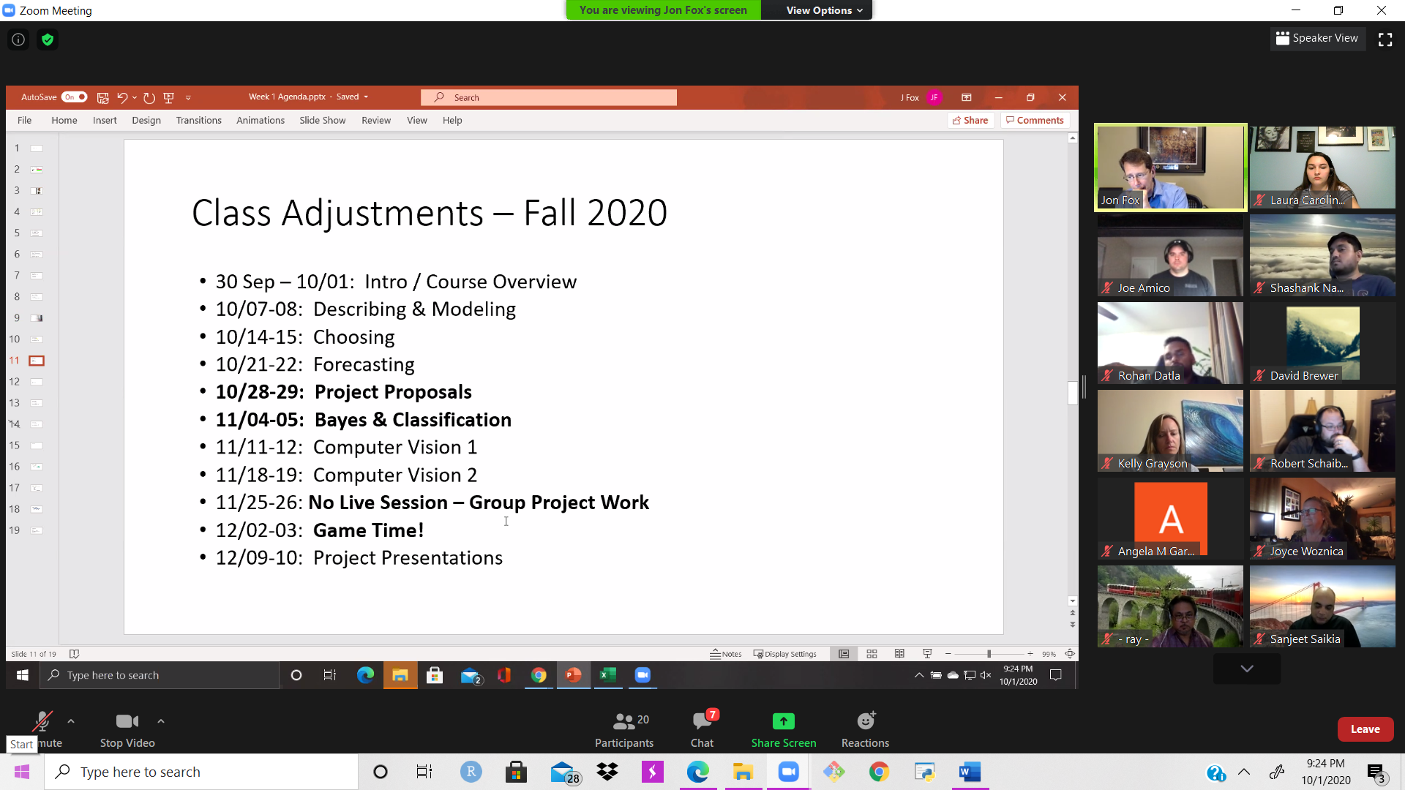

# Week 2

* Helpful Links
  + <https://github.com/2SUBDA>
  + <https://colab.research.google.com/notebooks/intro.ipynb>
  + <https://seaborb.pydata.org>
  + <https://plotly.com/python>
  + <https://rapids.ai>

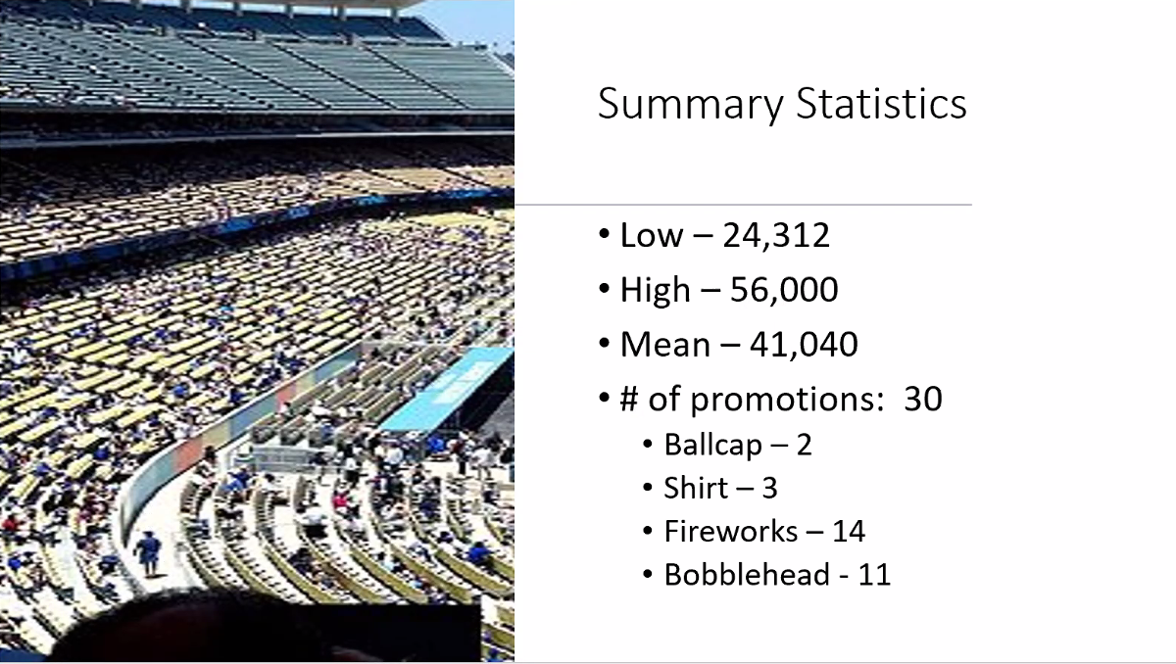

# Week 3

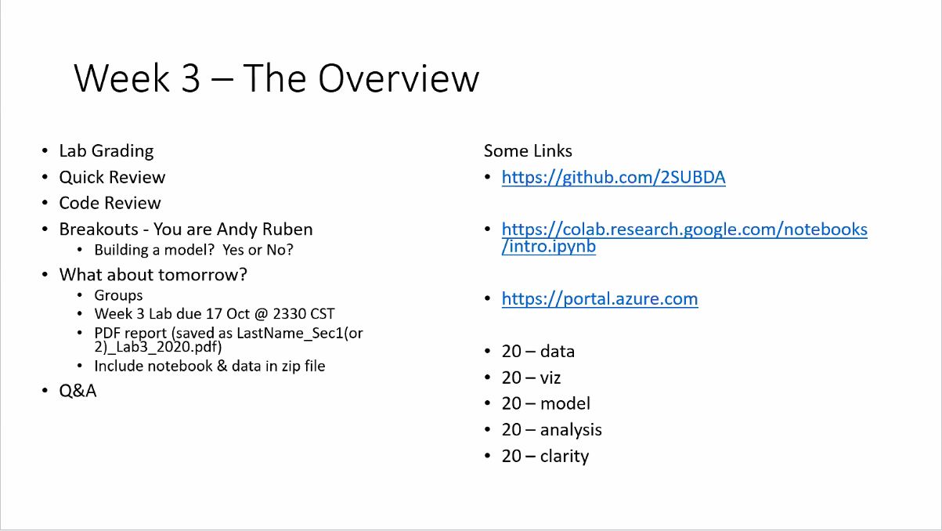

* 4-6 page report
* linear model, decision tree, neural

